Date | 04 October 2026
Team ID | SWTID-2026-4732
Project Name | Implement Client Script & UI Policy (Incident)
Team Leader | Karuppa Sami Kasi Visvanathan S
Team member | Bala M
Team member | Saifur Rahuman Z
Team member | Karthik T
Maximum mark | 5

Preventing Invalid Submissions: Implementing Save-Time Validation

The fourth activity focuses on preventing Incident records from being submitted when important information is missing. For High Impact Incidents, the Assigned To field is required to ensure that the Incident has an appropriate person responsible for handling it.

The existing manual approach may allow users to attempt saving an Incident without completing the required information. This can result in incomplete records and may affect Incident handling and resolution.

The idea was developed to introduce an onSubmit Client Script that validates the Assigned To field before an Incident is saved.

The project user story is: As an Incident Management user, I want the system to prevent High Impact Incidents from being saved when Assigned To is empty so that every High Impact Incident has the required assignment information.

The proposed solution uses a Client Script named “Prevent save if Assigned To missing”. The script runs when the user attempts to save an Incident. If the Impact is High and the Assigned To field is empty, the script displays an error message and prevents the record from being submitted.

If the required condition is satisfied, the Incident is allowed to save normally.

This validation improves data integrity by ensuring that High Impact Incidents contain the required assignment information before submission. It also provides immediate feedback to users instead of allowing incomplete records to enter the system.

Screenshot:

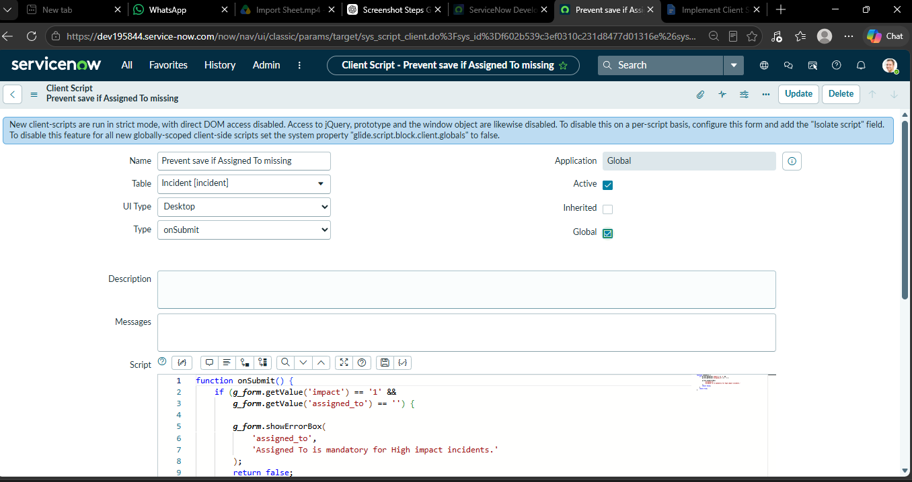

Decision Tree Flowchart (Visual Style):

[ User Attempts to Save Incident ]
|
V
< Is Impact = High? >
/ \
YES NO
/ \
V V
< Is 'Assigned To' Empty? > [ Proceed to Save ]
/ \ [ Record Normally ]
YES NO
/ \
V V
[ Show Error Message ] [ Proceed to Save ]

[ & Prevent Save ] [ Record Normally ]

JavaScript:

function onSubmit() {

if (g_form.getValue('impact') == '1' && g_form.getValue('assigned_to') == '') {

g_form.showErrorBox('assigned_to', 'Assigned To is mandatory for High impact incidents.');

return false;

}

return true;

}

onSubmit Client Script Configuration

Configuration Item | Details
Script Name | Prevent save if Assigned To missing
Script Type | onSubmit
Target Table | Incident
Validation Condition | Impact = '1 - High' AND Assigned To is Empty
Execution Action | Prevent form submission (Abort save)
Error Message Displayed | "Assigned To is mandatory for High impact incidents."

